Cybersecurity Foundations

Introduction
Cybersecurity is the practice of protecting systems, networks and data from digital attacks. As technology advances, cyber threats continue to grow, making cybersecurity an essential field in today’s digital world.

Cybersecurity Career Paths
Cybersecurity offers multiple career opportunities depending on skills and specialization:
Security Analyst – Monitors systems and detects threats
Ethical Hacker (Penetration Tester) – Simulates attacks to find vulnerabilities
Network Security Engineer – Secures network infrastructure
SOC Analyst – Works in a Security Operations Center monitoring incidents
These roles are important in preventing, detecting, and responding to cyber threats.

Types of Cyber Attacks
Cyber attacks are malicious attempts to damage or access systems. Common types include:
Phishing – Fake emails or messages to steal information
Malware – Malicious software like viruses or spyware
Ransomware – Locks files and demands payment
DDoS (Distributed Denial of Service) – Overloads servers
Man-in-the-Middle (MITM) – Intercepts communication

Ethical Hacking Principles
Ethical hacking involves legally testing systems for vulnerabilities. Key principles include:
Authorization – Always have permission
Confidentiality – Protect sensitive data
Reporting – Inform organizations of weaknesses
Non-malicious intent – Improve security, not harm

Top 10 Cyber Threats
Phishing - Deceptive emails or messages tricking users into revealing sensitive information.
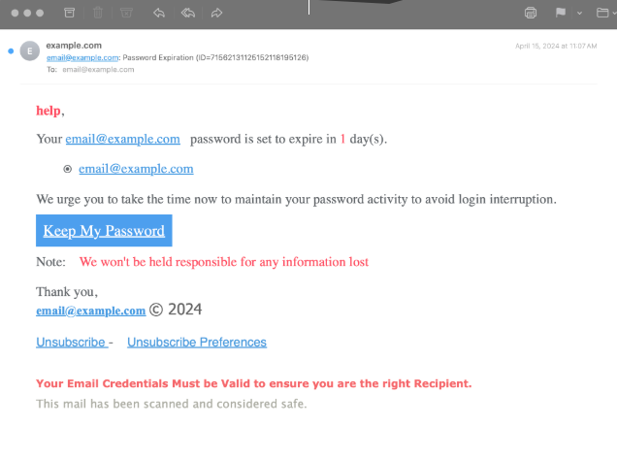
Malware - Malicious software designed to damage or exploit systems.
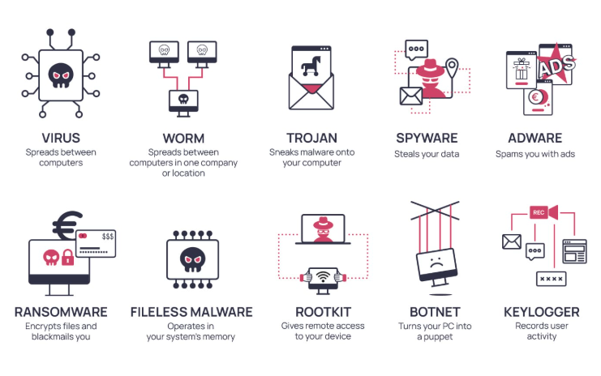
Ransomware - Malware that locks data and demands payment for release.

DDoS attacks - - Overwhelming a system with traffic to disrupt services.
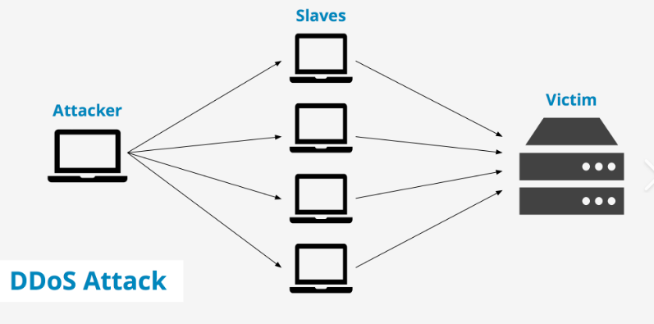

SQL Injection - Exploiting database queries to gain unauthorized access.
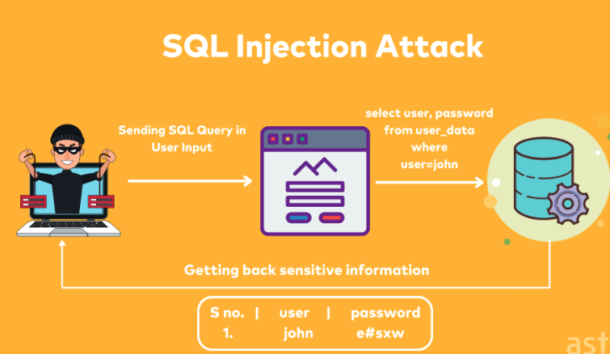
Zero-Day Exploits - Attacks targeting unknown or unpatched vulnerabilities.
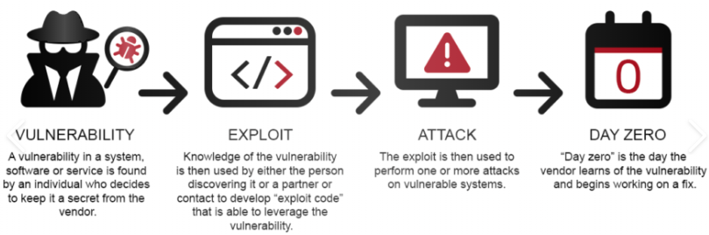

Man-in-the-Middle Attacks - Intercepting communication between two parties.
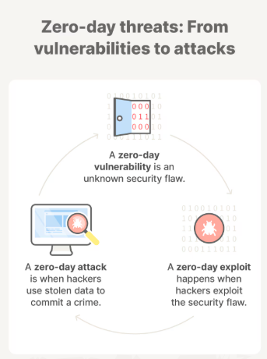

Password Attacks - Cracking or stealing login credentials.
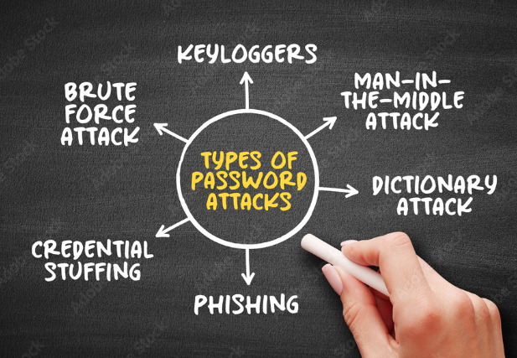

Insider Threats - Malicious or careless actions from within an organization.
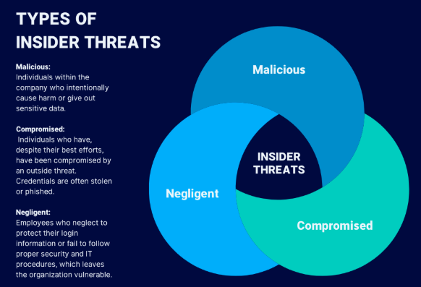
Social Engineering - Manipulating people into compromising security.
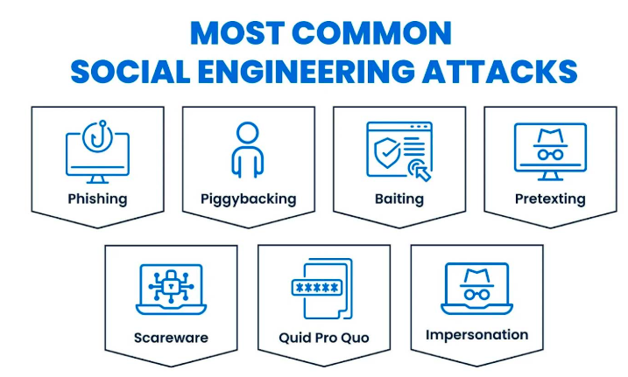

Conclusion
Cybersecurity is critical in protecting digital systems. Understanding threats, career paths and ethical practices helps build a strong foundation in the field.

References
https://www.cisco.com/site/us/en/learn/topics/security/what-is-cybersecurity.html
https://www.kaspersky.com/resource-center/definitions/what-is-cyber-security
https://www.ibm.com/think/topics/cyber-attack
https://owasp.org/www-project-top-ten/
https://www.eccouncil.org/cybersecurity-exchange/ethical-hacking/what-is-ethical-hacking/

